|  |  |
| --- | --- |
| **Godox QS400II Flash**  Đèn Flash Godox QS400II   Đèn Godox QS400II  Đèn Godox QS400II -3 Đèn Godox QS400II -1 Đèn Godox QS400II -3 | **Featured information:**  Godox lamps are QS400II a balanced flash source, providing natural light like daylight. The lamp has a color temperature of 5600K that can adjust the light from 5-100% with professional and convenient features, providing the best light source when shooting.  **Price : 150$**  **Specifications:**   * **Detail:** Optional X1, FT-16, XT16 transmitter, Color temperature 5600K, Lamp return time from 0.3 - 1.5 seconds, Flash duration: 1/800 to 1/2000 sec |

**Description:**

**The Godox QS400II**

The Godox QS400II is a balanced flash that provides natural light like daylight. The lamp has a color temperature of 5600K that can adjust the light from 5-100% with professional and convenient features, providing the best light source when shooting. The 6.0 lb QS400II makes it easy to assemble accessories, Bowens mounts are compatible with a variety of devices.

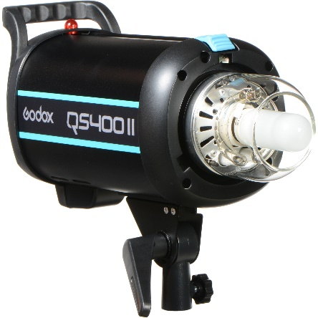

Godox QS400II uses TTL X1 wireless triggers and XT16 and FT16 remote controllers to control power, lighting and light activation. With the remote control, you can control the lights easily. Besides, the light also integrates 32 channels and 16 groups to limit interference from other devices.